Diary Entry 1 Employability Game – Gamble

The game premise - using employability skills that you need.

When designing the game the team decided to use “<https://draw.chat/>”. Everyone in the team were online, in different places, so this allowed the team to be able to work together on the project. It also allowed anyone to be able to contribute towards the design of the game.

The Rules:

The aim of the game is to finish with the most money at the end. This is done by making gambles whilst traveling around the board to try and increase the amount of money you have.

* Every player starts with £1000
* When placing a bet the player can only place it in the hundreds, e.g. £100, £200, £1300, so they cannot make a bet of £150.
* Each turn the player rolls the dice and moves the amount of spaces that they roll.
* Each turn after rolling the dice, pick up a card and do what it says.

In this game there are different cards that the player can pick up which require you to take a different action. There are two type of cards within the deck there are “self” cards and “someone else” cards. If the card is a “self” card it means that the player must complete the card themselves. If the card is a “someone else” card it means that the payer whose turn it is gets to choose which player other then themselves has to complete the cards action.

The Cards:

* Gain £100 – get £100.
* Lose £100 – lose £100.
* Double or nothing – make a bet then roll the dice, if it is even – Gain double what you betted, if it is odd – lose everything you betted.
* Gamble – make a bet then roll the dice, if it is even – Gain 1.5 times what you betted, if it is odd – lose half what you betted.
* Safe bet – roll the dice, if it is a 1 or a 6 gain £500.
* Nothing – You do nothing.

**A**

**B**

**C**

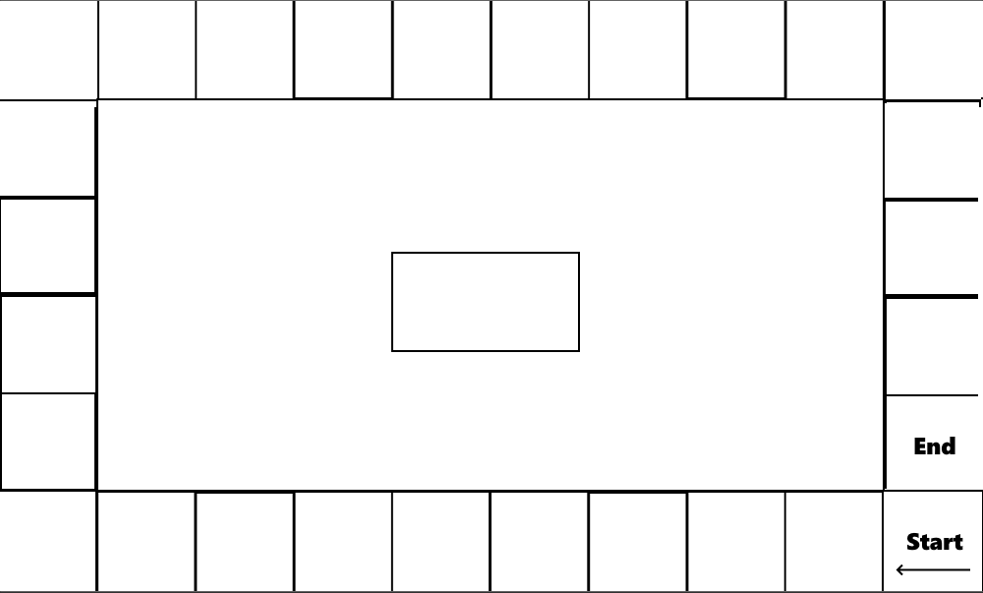

**Figure 1** – Picture of the design of the game board. [A] The start position, [B] The end position, [C] Where the pile of game cards will be.

On this project working in a team made the idea and creation process much easier and faster then just doing it by ones self. The team worked well together one person in the team did not have a microphone, but this did not stop the team as it meant that they would just communicate by text instead of by voice. Being a part of a team made the project slightly less nerve-racking as the everyone took responsibility for the project meaning that nerves were spread throughout the team and not just on a single person.

From creating this game I learnt more about the employability skills of communication and teamwork. Teamwork and communication go hand in hand , as to able to have good teamwork within a team, the team must communicate with each other. The main place this happened was when trying to create the idea for the game, everyone came up with different ideas which then inspired the other people in the team to come up with more this allowed the ideas to bounce from each team member coming up with an idea for a game faster then it would of taken if a single member of the team tried to come up with one.

Next time we need to improve on time management as we were not able to create a working version of the game for it to be able to game tested. Improving on the time management may mean that we have less time to try and create the idea for the game, but it will allow us to create a minimum viable product to be tested, it will also allow for more time to be put into the presentation as, the presentation was rushed towards the end of the project time.

Team Members:

* James Wilson
* Jamie Soden
* Akash Sroay